**Touch Screen and wireless communication based Personal assistant for**

**Dumb and illiterate in Airlines**

**Abstract:**

The main purpose of using this project is to give assistance to the illiterate/dumb people traveling by Airlines. So, in this project we are using a device that helps them in expressing their needs like coffee, tea, drinks etc to the concerned staff of airlines in the flight. The major technology which we are using in this project is RF wireless communication with interface of touch screen. By the usage of Touch screen Display even reduces the difficulty to airhostess in receiving the customers with different languages and the Message can be send for long distance( within the plane) by using RF Technology.

A Touch Screen is an electronic visual display that can detect the presence and location of a touch within the display area. The term generally refers to touching the display of the device with a finger or hand. The project is built around the PIC16F877A micro controller from Atmel. This micro controller provides all the functionality of the display and wireless control. This projectconsists of RF based system that transmits the wireless signals according to the input given by the user using touch screen.

At the receiver end the information will be displayed on LCD. Here when user sends his need through touch screen, then microcontroller transmits that information through RF transmitter. The information received by the RF receiver will be displayed on LCD. This project uses regulated 5V, 1A power supply. 7805 three terminal voltage regulator is used for voltage regulation. Bridge type full wave rectifier is used to rectify the ac output of secondary of 230/12V step down transformer.

**BLOCK DIAGRAM UNIT:**

**Transmitter Unit:**

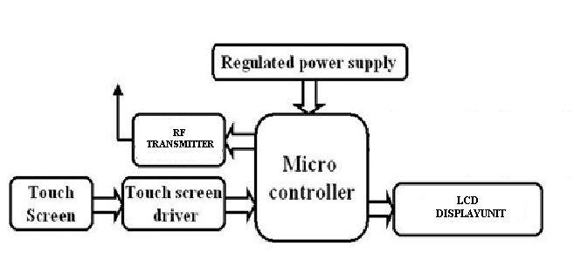

**Receiver Unit:**

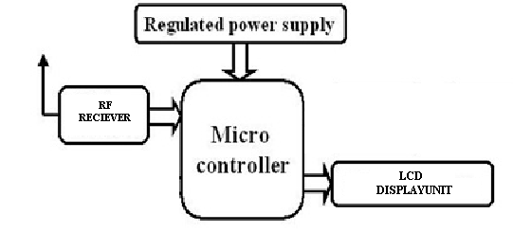

**Advantages:**

Its operation is simple and easy

It is less expensive

It is highly efficient

Power required is less

Faster and secure data transmission

User friendly and easy to install

**Applications:**

It is used in airlines

It is applicable in hospitals

It is used in restaurents

Very useful even for illiterates

Helpful in abroad to express user’s needs

Deaf and dump people also can interact with others.

Can be used with any languages